DATA SHEET
SAFELIFE ‘DISABLED TOILET’ ALARM KIT
MODEL SKU: A-CALL-TO LIGHT-KIT
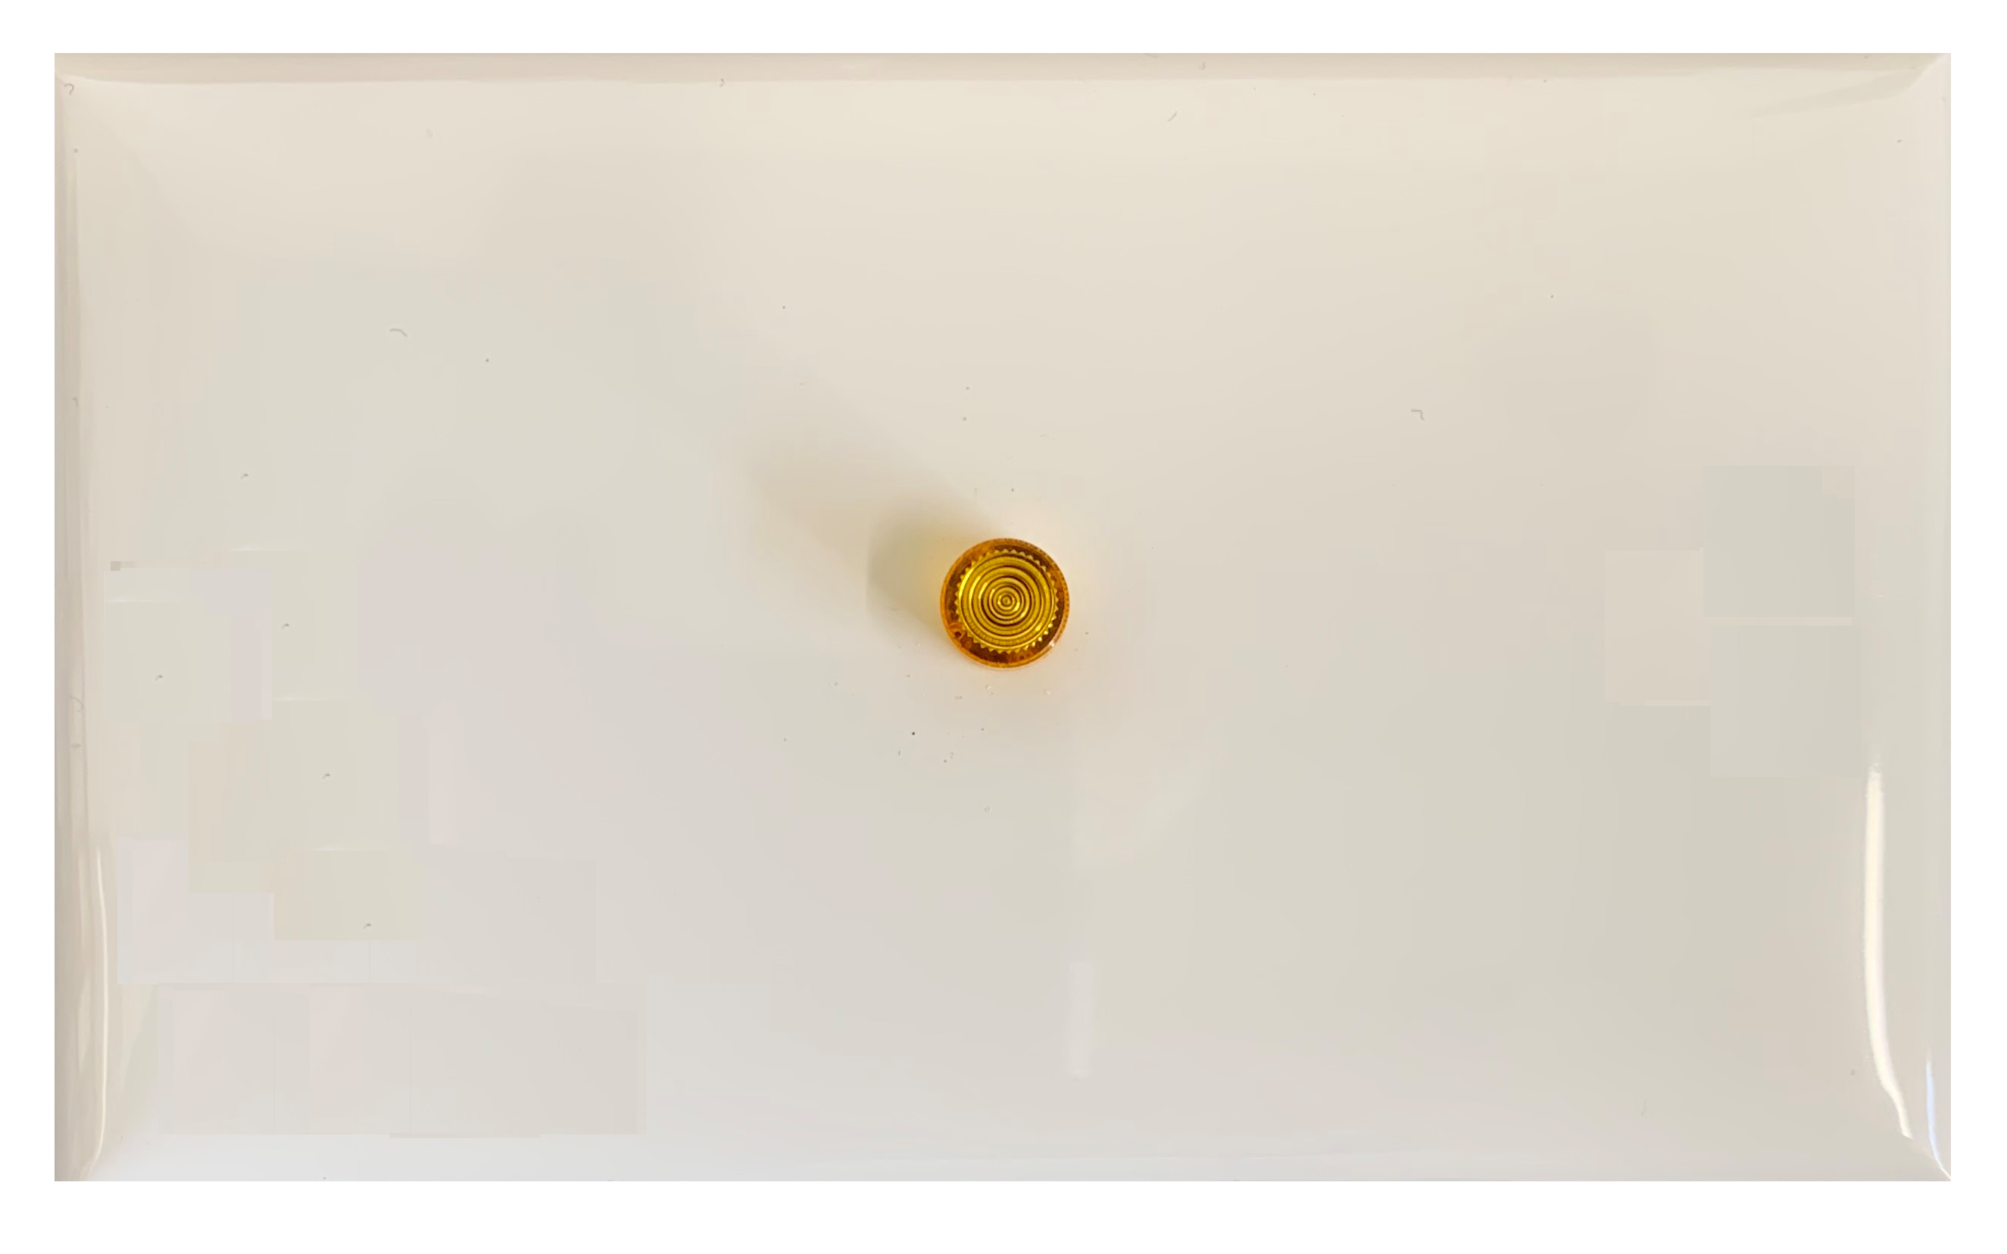
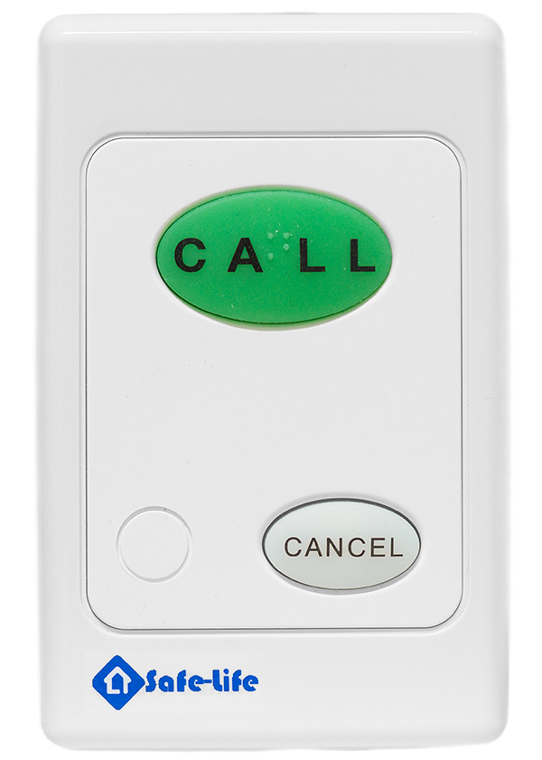

The Disabled-Toilet Alarm Kit includes a Model H3 Call Point plus a 12v plug-pack power source and requires a cable connection from the call point to the over door light/s. See attached diagram. The distance between the call point and over door lights can be up to 400 meters.
The over-door light is fitted with a buzzer and will continue to flash and sound until the call point's cancel button is pressed. The silicon call button includes a Braille marking and is treated with long term anti-bacterial/anti-fungal infection control processing and is back-lit.
The call-point (with the choice of 3 Call Buttons) can also provide a higher-level alert status by the attending person simultaneously pressing both the call and cancel buttons. Meanwhile the call-point provides an immediate beep and an ongoing button flash to provide reassurance that the call has been despatched. This escalated call priority will flash and buzz the overdoor light assembly at twice the cadence rate.
Multiple over-door light assemblies are often required, typically one outside the toilet and another in Reception. This requirement should be identified at time of purchase.
The following system components and options are available and should also be identified at time of purchase.
- CALL-POINT HP3. This is an essential part of the system with following options.
CALL = (Green Button - CALL)
EMG = (Red Button - EMERGENCY)
ASS = (Yellow Button - ASSIST)

- PENDANT CORD JACK (Option). The call point can also be supplied with a pendant cord jack which allows an optional corded pendant to be connected. This is ideal for a patient to call for help in a day surgery situation.
PC = Pendant Cord Jack. Select from Safelife range of Pendant Cords
Note. Alternatively, Wireless Pendants may also be deployed in order to trigger a call-point within typically 20M wireless range.

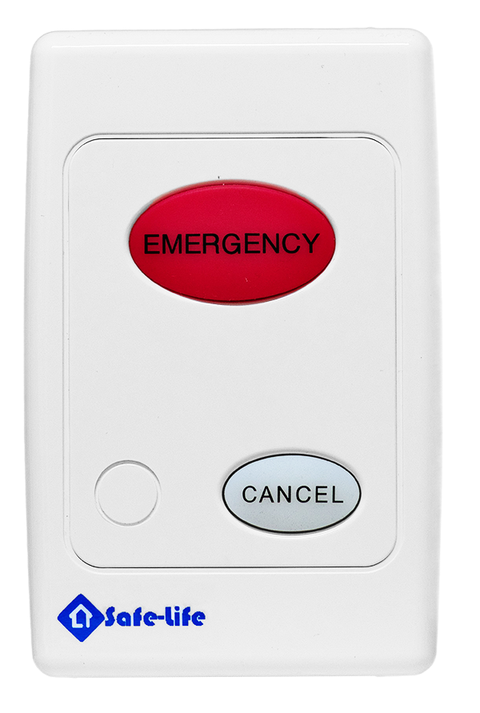
- OVERDOOR LIGHT. ODL-01- BUZZ. A single unit is essential to the system and a second being optional. It comprises a single 5mm “Superbrite” LED in Yellow LED housing and mounted on a 13mm mounting block. It is intended for ceiling or overdoor mounting outside of the toilet ensuring an optimum viewing location.

A Call Point with Red Emergency Call Button and no pendant cord jack.

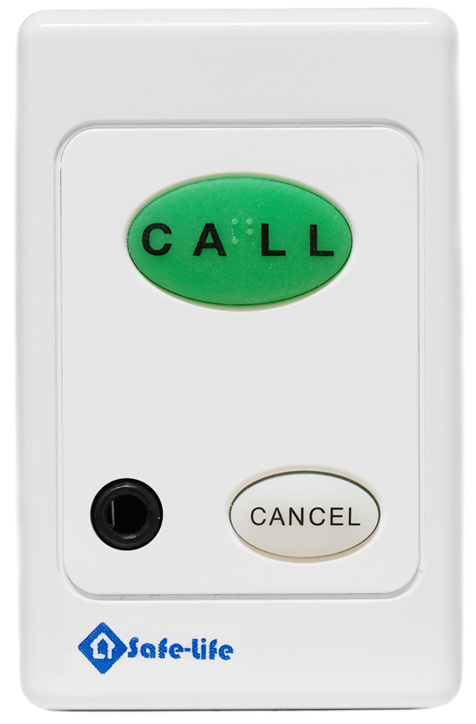
A Call Point with Green Call Button and including a cord pendant Jack.

